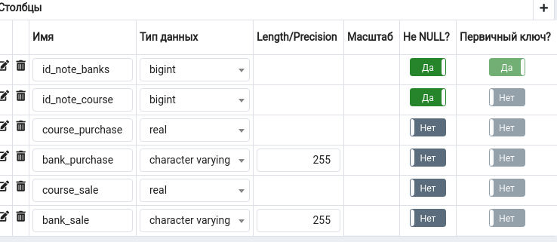 courseBanks

id_note_banks

id_note_course

course_purchase

bank_purchase

course_sale

bank_sale

courseCB

id_note_сourse

id_currency

course_currency

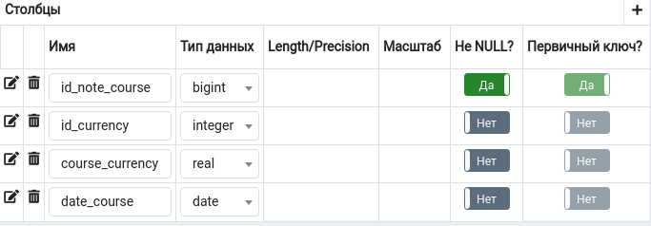date_course